**Experiment No:** 03

**Experiment Name:**

1. Curve fitting of straight line
2. Curve fitting of parabola

**Objective:**

In this lab,we can learn how to find out the result of straight line in Curve fitting.As well as find out the result of curve fitting of parabola.

**Problem Code:**

clc;

clear all;

close all;

n=input('Enter the number of point : ');

for i=1:1:n

fprintf('Enter number x%d : ',i);

x(i)=input('');

fprintf('Enter number y%d : ',i);

y(i)=input('');

end;

plot(x,y);

xlabel('X Axis');

ylabel('Y Axis');

title('Straight Line');

tx = 0;

ty = 0;

xy = 0;

x2 = 0;

for i=1:1:n

tx = tx + x(i);

ty = ty + y(i);

xy = xy + x(i)*y(i);

x2 = x2 + x(i)*x(i);

end;

a1=(n*xy-tx*ty)/(n*x2-tx*tx);

a0=(ty-a1*tx)/n;

for i=1:1:n

y(i)=a1*x(i)+a0;

fprintf('yi : %f ',y(i));

end;

hold on;

plot(x,y);

xlabel('X - Axis');

ylabel('Y - Axis');

title('Final Line');

fprintf('value final : y = %fx + %f',a1,a0);

**Output**: Enter the number of point : 3

Enter number x1 : -2

Enter number y1 : 3

Enter number x2 : 4

Enter number y2 : 8

Enter number x3 : 2

Enter number y3 : 3

yi : 2.285714 yi : 6.571429 yi : 5.142857 value final : y = 0.714286x + 3.714286>>

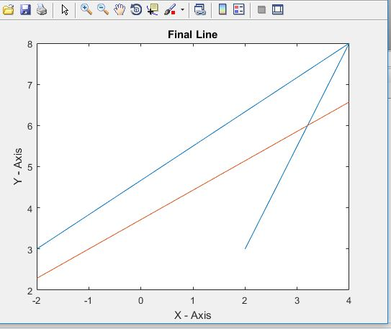

**ii)Parabola**

clc;

clear all;

close all;

n = input('Enter the number of point : ');

for i=1:1:n

fprintf('Enter point x%d : ',i);

x(i)=input('');

fprintf('Enter point y%d : ',i);

y(i)=input('');

end;

%subplot(2,1,1);

plot(x,y);

xlabel('X- Axis');

ylabel('Y - Axis');

title('Parabola');

tx = 0;

ty = 0;

xy = 0;

x2 = 0;

x2_y = 0;

x3 = 0;

x4 = 0;

for i=1:1:n

tx = tx + x(i);

ty = ty + y(i);

xy = xy + x(i)*y(i);

x2 = x2 + x(i)*x(i);

x2_y = x2_y + x(i)*x(i)*y(i);

x3 = x3 + x(i)*x(i)*x(i);

x4 = x4 + x(i)*x(i)*x(i)*x(i);

end;

fprintf('x : %d \ny : %d \nxy : %d \nx^2 : %d \nx^2y : %d \nx^3 : %d \nx^4 : %d\n',tx,ty,xy,x2,x2_y,x3,x4);

p=tx;

q=ty;

r=xy;

s=x2;

t=x2_y;

u=x3;

v=x4;

a2=(((p*t-s*r)*(n*s-p*p))-((r*n-p*q)*(u*p-s*s)))/(((p*v-u*s)*(n*s-p*p))-((n*u-p*s)*(u*p-s*s)));

a1=(p*t-s*r-a2*p*v+a2*u*s)/(u*p-s*s);

a0=(q-a1*p-a2*s)/n;

fprintf('a0 = %f\na1 = %f\na2 = %f \n',a0,a1,a2);

fprintf('Equation : y = %f + %fx + %fx^2 \n',a0,a1,a2);

for i=1:1:n

z(i)=a0+a1*x(i)+a2*x(i)*x(i);

end;

hold on;

%subplot(2,1,2);

plot(x,z);

xlabel('X- Axis');

ylabel('Y - Axis');

title('Parabola');

**Output:**

Enter the number of point : 4

Enter point x1 : -2

Enter point y1 : 1

Enter point x2 : 3

Enter point y2 : 4

Enter point x3 : 5

Enter point y3 : 6

Enter point x4 : 8

Enter point y4 : 9

x : 14

y : 20

xy : 112

x^2 : 102

x^2y : 766

x^3 : 656

x^4 : 4818

a0 = 2.019573

a1 = 0.589680

a2 = 0.035943

Equation : y = 2.019573 + 0.589680x + 0.035943x^2

>>

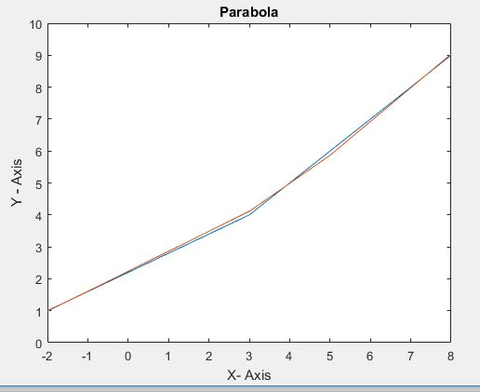

**Discussion:**

In this lab we will discuss about Curve fitting of Straight line and Parabola.The process of finding the equ of the curve of best fit,which maybe most suitable for predicting the unknown values,is known as curve fitting.At the time of solving the problem we face some problem but our honorable teacher help us a lot to solve the issue.